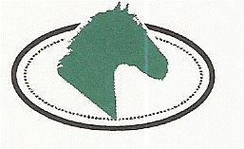
Clonshire Equestrian Centre
Adare,
Co. Limerick
Ireland

Adult Day Camp Programme Option 2016
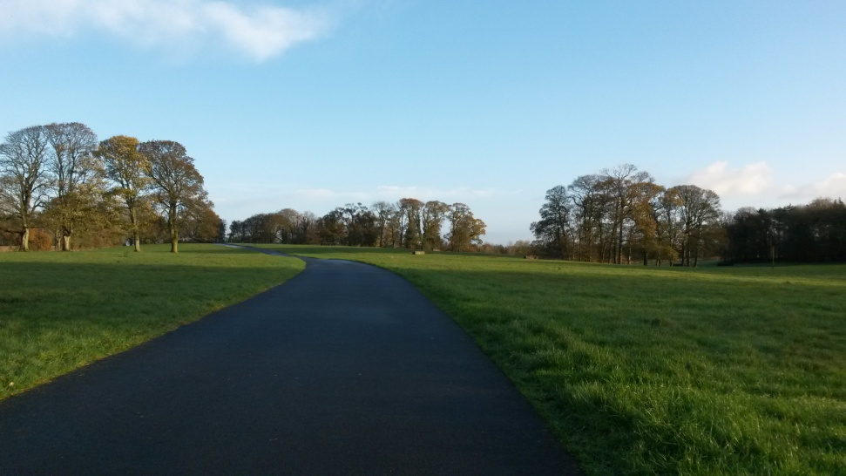

Clonshire Equestrian Centre is owned by the Co Limerick Hunt Club and is a not-for-profit business. We are well established as one of the most successful Horse Riding Centres in Ireland, set in 120 acres of green Parkland in the Golden Vale of Ireland. We are a registered Training and Examination Centre for career programmes.
Our facilities include:
- 2 indoor riding arenas with viewing areas
- 1 very extensive outdoor all weather arena
- 1 grass Showjumping arena for competitions
- 70 indoor stables with washbays, tack rooms and feed sheds
- Automatic Horsewalker
- Coffeeroom, bathrooms, showers
- Lecture room and class room

Horses:
Our horses are Irish Sport Horses and Connemara Ponies, known worldwide for their excellent temperament and willingness to help riders improve their riding. Our horses are all expertly fitted with a comfortable saddle by a Master Saddler and have regular checkups. Our farrier and vet attend regularly to ensure our horses are in full health. We also have several horses and ponies for sale and we sell to clients throughout the world.

Staff:
We are fully approved by the Association of Irish Riding Schools and The British Horse Society. In Clonshire Equestrian Centre we are very proud of our excellent safety record. Our staff are fully qualified, having attained their qualifications through The British Horse Society and the Equestrian Federation of Ireland.

Accommodation on site is suitable for unaccompanied children who wish to take part in our English with Horse Riding Programmes. This is fully supervised with a House Keeper and a Minder to ensure each child has a good fun learning experience.

Adult Riding Holiday Programme:
This programme is suitable for riders wishing to improve their riding skills in a structured and safe environment. The first session of this programme is an assessment, where the instructor and rider can agree a progressive programme for the week. This will include flatwork, dressage, showjumping, cross-country riding and hacking through the Irish countryside. We would recommend the Dunraven Arms Hotel (Winner of Best Irish Hotel 2013) as a great place to stay while participating in this programme.
Daily Schedule:
- 9.30 – arrive at the stables and groom and tack up (supervised)
- 9.45 – Riding session – assessment, followed by progressive sessions in dressage, showjumping and general riding improvement
- 11.00 – Hack out in the countryside, to include cross country jumping if desired
- Lunch Break – Hotel can provide picnic lunch or return to the village by hired car or taxi for a variety of restaurants.
- 2.15 – Riding session – either a lesson or a ride in the country.
If riders want to take an afternoon off to do some sightseeing, we can organise this for you.
This programme runs daily from Monday – Friday but can be extended by arrangement.

