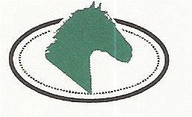
Clonshire Equestrian Centre
Adare,
Co. Limerick
Ireland
00-353-61396770

Non-Residential Pony Camp Option 2016
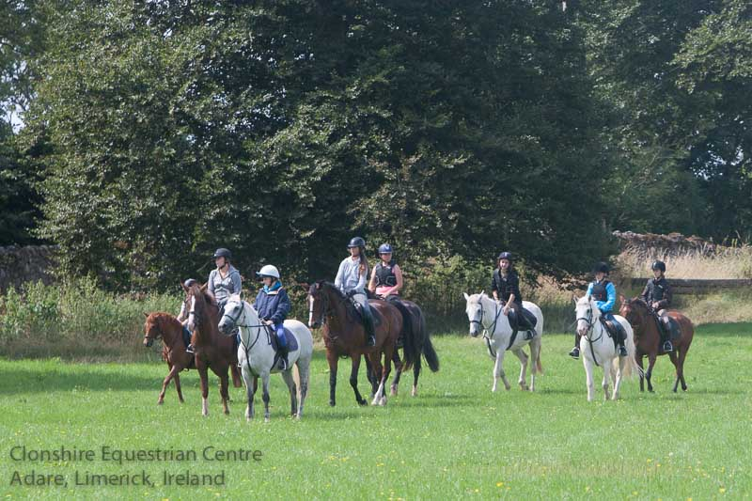

Clonshire Equestrian Centre is owned by the Co Limerick Hunt Club and is a not-for-profit business. We are well established as one of the most successful Horse Riding Centres in Ireland, set in 120 acres of green Parkland in the Golden Vale of Ireland. We are a registered Training and Examination Centre for career programmes.
Our facilities include:
- 2 indoor riding arenas with viewing areas
- 1 very extensive outdoor all weather arena
- 1 grass Showjumping arena for competitions
- 70 indoor stables with wash-bays, tack rooms and feed sheds
- Automatic Horse-walker
- Coffee-room, bathrooms, showers
- Lecture room and class room
Horses:
Our horses are Irish Sport Horses and Connemara Ponies, known worldwide for their excellent temperament and willingness to help riders improve their riding. Our horses are all expertly fitted with a comfortable saddle by a Master Saddler and have regular checkups. Our farrier and vet attend regularly to ensure our horses are in full health. We also have several horses and ponies for sale and we sell to clients throughout the world.

Staff:
We are fully approved by the Association of Irish Riding Schools and The British Horse Society. In Clonshire Equestrian Centre we are very proud of our excellent safety record. Our staff are fully qualified, having attained their qualifications through The British Horse Society and the Equestrian Federation of Ireland.

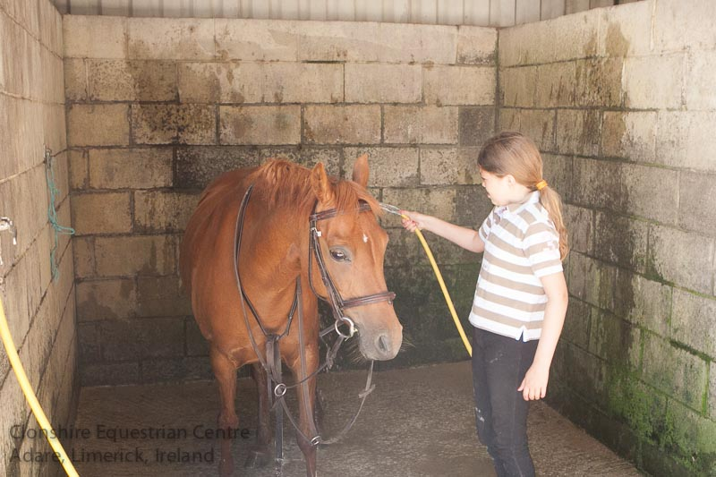

Children’s Day Camp:
We welcome children (8years – 18 years) from overseas to come and enjoy the fun and excitement of riding and looking after our ponies in our Pony Camp. Our young guests are supervised at all times to ensure that all activities are carried out safely.
Daily Schedule:
- 9:45am Meet up and get ready for the day
- 10:00am First riding lesson of the day, arena session with one of our instructors
- 11:00am Second riding lesson of the day, go for a ride in our extensive parkland
- 12:00pm Stable management with one of our instructors
- 1:00pm Lunch Break, Make sure to bring lots to eat and drink as lots of horse riding can make you very hungry!!
- 2:00pm Third riding lesson of the day, an arena session followed by a ride outdoors
- 3:00pm Stable management/pony games
On the last day there is a Competition and Assessment for the riders and they are awarded with a Clonshire Course Completion Certificate and Rosette.

