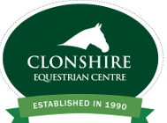

Clonshire Equestrian Centre
Interschools Showjumping Competition
Friday 1st November 2019
Primary School Team Competition Entry Form

Please complete form using Block Capitals

Name of School:___________________________ Team Name:__________________

Junior (60cm) : ☐ Novice (80cm) Competition: ☐

Competitors Name | Date of Birth | Name of Horse
1.
2.
3.
4.
Chef d’Equipe:
Email Address:
Telephone No:

I hereby confirm that all students above are currently in full time Primary education:
School Principal: __________________ School Stamp:

Signature of School Principal: ______________________________

Please return completed form with cheque €80 made payable to Clonshire Equestrian Centre by 25th October 2019 to:
Interschools Competition, Clonshire Equestrian Centre, Adare, Co. Limerick

